Customer Behavior & Purchase Pattern Analysis
End-to-End Data Analytics Project Report
Project Tools: Jupyter Notebook, MySQL Workbench, Power BI | Dataset Size: 3,900 Records
Primary Focus: Retail Transactional Analysis | Status: Complete Analysis & Findings

1. Executive Summary & Core Highlights
This project delivers an end-to-end evaluation of retail customer behavior and purchasing patterns. The workflow convers raw data preprocessing in Python (Jupyter Notebook), analytical querying within MySQL Workbench, and interactive performance tracking in Power BI Desktop.
Total Revenue / Volume | Customer Base | Avg. Basket Quantity | Subscriber Share
233K  (3,900 Orders) | 4,000  Unique Users | 59.76  Per Purchase | 26.88%  (63K Share)

Key Finding: Clothing is the top-performing category, generating $104K in sales volume across 3.40K customer interactions, followed by Accessories ($74K) and Footwear ($36K). Notably, non-subscribers generate 73.12% ($170K) of total volume, highlighting a major strategic opportunity for subscription conversion.
2. Data Preprocessing (Jupyter Notebook)
Before loading the dataset into MySQL Workbench, raw transactional records were cleaned and structured in Jupyter Notebook using Pandas:
- Null & Rating Cleaning: Handled missing values across review ratings, shipping options, and promotional discounts to prevent analytical bias in Power Bi Dashboard.
- Renaming Columns: Converted raw column names to standard snake_case formats (e.g., purchase_amount, review_rating) for seamless querying.
- Age Grouping: Grouped customer ages into simple age groups (Young Adult, Adult, Middle Aged, Senior) to enable age-based behavioral breakdown.
- Fixing Data Types: Changed purchase numbers into proper numeric format and converted binary flags into standardized string values.
3. Database Queries & Findings (MySQL)
The following SQL queries were executed against the customer table in MySQL Workbench to answer key business questions:
Query 01. Gender Revenue Share
select gender, sum(purchase_amount)
from customer
group by gender;
Takeaway: Provides overall volume distribution across gender segments to inform targeted marketing campaigns.
Query 02. Discount Sensitivity
select customer_id, purchase_amount
from customer
where discount_applied = 'Yes'
and purchase_amount > (select avg(purchase_amount) from customer);
Takeaway: Identifies high-value buyers who utilize discounts while maintaining basket sizes above the baseline average of 59.76.
Query 03. Product Ratings
select item_purchased, round(avg(review_rating), 2) as average_product_rating
from customer
group by item_purchased
order by avg(review_rating) desc
limit 5;
Takeaway: Top-rated products include Gloves (3.86), Sandals (3.84), Boots (3.82), Hat (3.80), and Skirt (3.78).
Query 04. Shipping Fulfillment Comparison
select avg(purchase_amount), shipping_type
from customer
where shipping_type in ('Standard', 'Express')
group by shipping_type;
Takeaway: Compares basket sizes across fulfillment types to evaluate if shipping speed correlates with larger order volumes.
Query 05. Subscription Impact Analysis
select subscription_status,
count(customer_id) as total_customers,
avg(purchase_amount) as avg_spend,
sum(purchase_amount) as total_revenue
from customer
group by subscription_status
order by total_revenue desc, avg_spend desc;
Takeaway: Non-subscribers make up $170K of our total revenue compared to $63K from subscribers. This shows that gaining new subscribers is the main way to boost our income.
Query 06. Discount Reliance per Product
select item_purchased,
100.0 * count(case when discount_applied = 'Yes' then item_purchased end) / count(*) as discount_purchase_percentage
from customer
group by item_purchased
order by discount_purchase_percentage desc
limit 5;
Takeaway: Highlights specific products that rely heavily on promotional discounts to drive volume.
Query 07. Customer Lifecycle Segmentation
with customer_type as (
select customer_id, previous_purchases,
case
when previous_purchases = 1 then 'New'
when previous_purchases between 2 and 10 then 'Returning'
else 'Loyal'
end as customer_segment
from customer
)
select customer_segment, count(*) as number_of_customers
from customer_type
group by customer_segment;
Takeaway: Categorizes customers into New, Returning, and Loyal groups to design custom rewards and retention plans.
Query 08. Category Top Performers
with ranked_items as (
select category, item_purchased, count(*) as total_purchases,
row_number() over (partition by category order by count(*) desc) as rank
from customer
group by category, item_purchased
)
select category, item_purchased, total_purchases
from ranked_items
where rank <= 3;
Takeaway: Uses window functions to uncover the top 3 best-selling products within each product category.
Query 09. Subscriber Likelihood
select subscription_status, count(customer_id) as repeated_buyers
from customer
where previous_purchases > 5
group by subscription_status;
Takeaway: Measures subscription conversion rates specifically among highly engaged repeat buyers (>5 orders).
Query 10. Demographic Revenue Contribution
select age_group, sum(purchase_amount) as total_revenue
from customer
group by age_group
order by total_revenue desc;
Takeaway: Breaks down purchase volume across different age groups (Young Adult, Adult, Middle Aged, Senior).
4. Visual Dashboard Insights (Power BI)
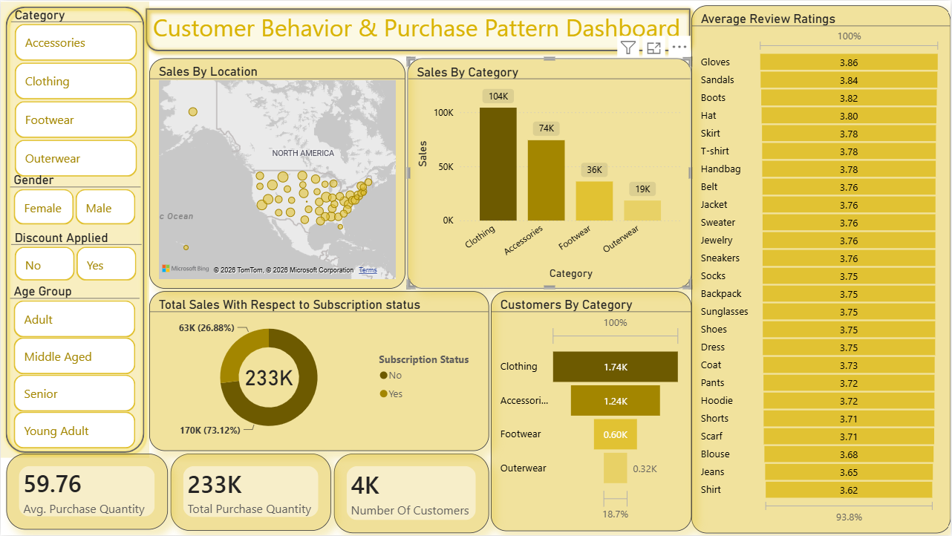

- Sales by Category: Clothing leads total sales with $104K volume, followed by Accessories ($74K), Footwear ($36K), and Outerwear ($19K).
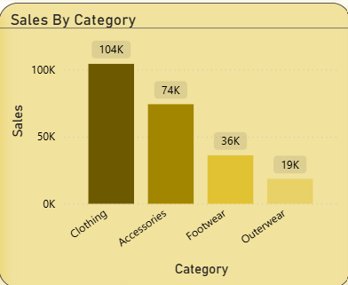

- Subscription Breakdown: Total volume of 233K is divided into 170K (73.12%) from non-subscribers versus 63K (26.88%) from active subscribers.
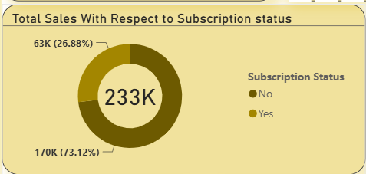

- Customer Interaction Volume: Clothing customer interactions reached 1.74k, Accessories 1.24k, Footwear 0.60k, and Outerwear 0.32k.
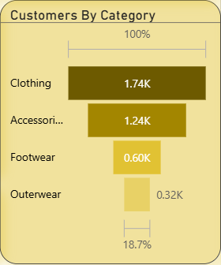

- Review Rating Distribution: Product satisfaction remains consistently high across categories, led by Gloves (3.86), Sandals (3.84), Boots (3.82), and Hats (3.80).
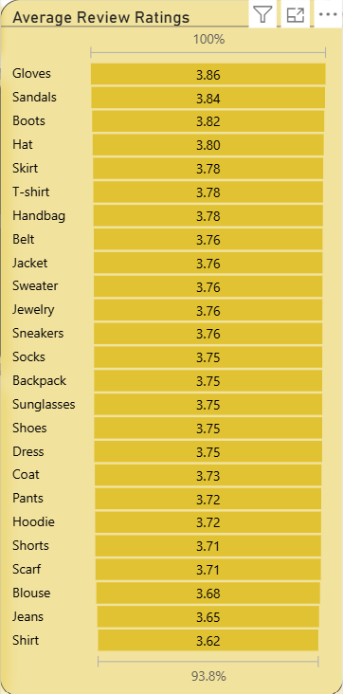
5. Strategic Recommendations
1. Target Likely Subscribers
Convert the 73.12% non-subscriber majority by launching targeted campaigns aimed at repeat buyers (>5 orders). Offer exclusive perks such as free expedited shipping or early access to new collections.
2. Optimize Top Product Stock & Features
Focus stock levels and main marketing features on clothing (104k in sales) and Accessories (74k in sales), which together make up over 76% of total revenue.
3. Implement Minimum Spend Threshold Promotions
For customers who spend above average ($59.76) with discounts applied, transition from flat discounts to threshold-based promotions (e.g., '$10 off on orders over $75') to systematically increase average order value.

